Knowing the Therapeutic Powers of Play
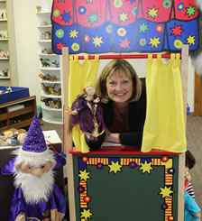
When we visit the website for the Association for Play Therapy (www.A4PT.org) we see ‘the dude’ and “Mental Health Professionals Applying the Therapeutic Power of Play.” (Emphasis added.) It seems rather intuitive, after all, that play therapists would be able to speak about how play has therapeutic power unto itself, and what that power is. Can we, though? If a parent asks you, right this minute, “why are you just ‘playing’ with my child?” what would you answer? “It’s the child’s natural language.” Or, “Toys are a child’s words, and play is their conversation.” Or, would you quote Plato? All laudable, well-rehearsed quotes of our world as play therapists. But does that answer the parent’s concerned question?
Charles Shaeffer and Athena Drewes edited, The Therapeutic Powers of Play: 20 Core Agents of Play, in 2014 (Second Edition) (https://books.google.com/books/about/The_Therapeutic_Powers_of_Play.html?) and it is a marvel of documentation about the fundamental issue of why we play. Taking this to heart, I have decided to enter into a crusade to get people talking about why we play: the therapeutic powers of play.
So, what are these powers? Knowing is sharing, so in a nutshell, there are four essential categories of powers:
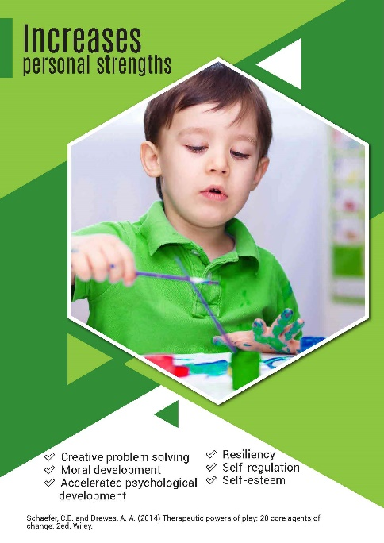

Play offers children creative ways to solve problems, enhances moral and psychological development and resiliency, and promotes self-regulation and self-esteem.

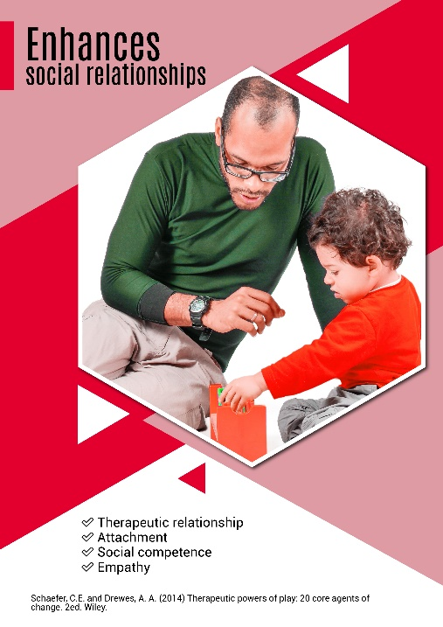
Through the therapeutic relationship, play builds social competency, attachment, and empathy.

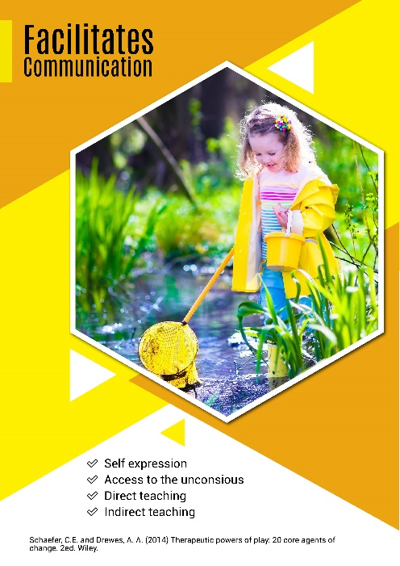

Play gives voice to self-expression, allows access to unconscious thoughts, and allows for direct and indirect teaching.

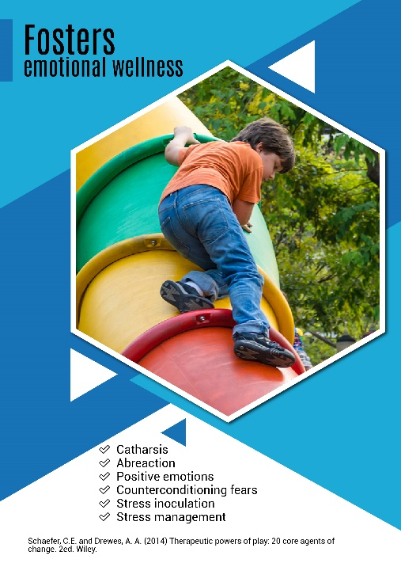

Play gives children space for catharsis and abreaction. Both positive and negative emotions are expressed, promoting stress management and overcoming fears.

These four posters are available to you to print in digital format and all together they may be ordered in a banner (Vistaprint $19.95). Just email me (drsusan@C4CG.net) to get them.
Here are some other ways that you can share the therapeutic powers of play with parents. In July I presented a pecha kucha (a what?). A ‘P-K’ is a sort of personal infomercial about anything you are passionate about; 20 slides and 6 minutes to tell your story. Here is a link to “Play is Work!” presented in Kalamazoo. Feel free to use this to explain what you do and why play is so powerful. https://www.pechakucha.org/cities/kalamazoo/events/5ae36f6efc57bd28ce32c234
There is also a video, The Therapeutic Powers of Play https://www.youtube.com/watch?v=wuu59E97igU created by our Australian play therapy counterparts, Kate Renshaw and Dr. Judi Parsons. Often sharing with parents in this form can be insightful and lower their concerns about play therapy.
Another learning opportunity will be available on October 16. Lessons from the Playroom presented by the Play Therapy Institute of Colorado will focus on the Therapeutic Powers of Play. It is a free webinar, just register at https://playtherapycolorado.com/.
Help me in my crusade – let´s get going and knowing the therapeutic powers of play!

